1. A website only allows users in the age bracket 18 to 21 inclusive to access its content. Write a method that accepts the age as an int argument and decides whether it is possible to access the site. Your method shall return a boolean value.
2. Write a method that uses a switch statement to return the cost of a product, where the method receives a product description as a string argument.

The cost of each product is listed below:

|  |  |
| --- | --- |
| Product Description | Cost |
| “Jeans” | 67.99 |
| “Jacket” | 68.99 |
| “Boots” | 34.99 |
| “Scarves”,”Belts”,”Socks” | These are all 10 |
| None of the above | Signal error with a cost of -999 |

1. Write a method named Zero that accepts an int array as an argument and stores the value 0 in each element.
2. Write a method:

static int Sum(int n1, int n2)

That returns the sum of all even numbers between the two integer arguments (inclusive) passed to it. For example:

Sum(2, 10) returns 30.

1. Write a method that accepts a stock-on-hand figure and a sales figure as int arguments. It will update the stock-on-hand figure by deducting the sales figure if there is sufficient stock to fulfil the sale. The method shall return true if the stock-on-hand figure has been updated, otherwise false.
2. Movie Ratings – 2D Array.

Create a 2D array which has movie ratings for 3 films. Each film has 3 reviews. Output the average rating for each film.

|  |  |  |  |
| --- | --- | --- | --- |
|  | Reviewer 1 | Reviewer 2 | Reviewer 3 |
| Film Title |  |  |  |
| Avengers Endgame | 3 | 4 | 5 |
| Spider-Man: Far From Home | 1 | 2 | 1 |
| Once Upon A Time in Hollywood | 5 | 4 | 2 |

1. Movie Ratings – Jagged Array.

As above but this time there is a jagged array.

|  |  |  |  |  |
| --- | --- | --- | --- | --- |
|  | Reviewer 1 | Reviewer 2 | Reviewer 3 | Reviewer 4 |
| Film Title |  |  |  |  |
| Avengers Endgame | 3 | 4 |  |  |
| Spider-Man: Far From Home | 1 | 2 | 1 | 3 |
| Once Upon A Time in Hollywood | 5 | 4 | 2 |  |

Use this code to define the jagged array

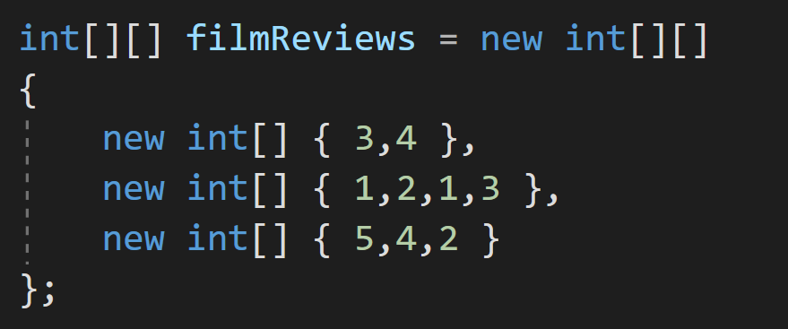

1. Lists. Write a program which asks the user to enter the name of the players on the team. Use a sentinel value of -1. Store the names in a List<string> collection. Output the names of the team in alphabetical order to the screen.
2. A program is required to read the sales data of a number of stores that is stored in a comma delimited file sales.txt. The program shall produce a report with the content and format outlined below. The performance description will be determined from the table below

|  |  |
| --- | --- |
| Total_sales | Performance |
| <1000 | “Needs attention” |
| 1000-1999 | “Moderate” |
| >2000 | “Very good” |

The file has the following format: store_id, total_sales

For example, the file with the following data will result in the report below. You will have to make a test file in notepad with this data.

S1,500

S2,1200

S3,1800

S4,800

S5,1900

****expected report based on this test data***

Sales Report

Store ID Sales Performance

S1 500 Needs attention

S2 1200 Moderate

S3 1800 Moderate

S4 800 Needs attention

s5 2900 Very good

Total Sales 7,200

Average Sales : 1,440